Lab #3 Exercises

Due Date: Sunday November 7th at midnight. You will record your answers in the Lab #3 Exercises ‘Quiz’ on our course Blackboard page.
Use this document to work out the activities/exercises and record your answers for quick reference while taking the ‘Quiz’.
When you are ready, navigate to Lab Assignments-> open the Lab #3 Exercises folder -> and open the Lab #3 Exercises quiz link located at the bottom.
This Lab #3 is worth 60 points.

*Important Note: Don’t wait until the last minute to attempt these lab exercises. If you have questions, email me sooner rather than later. Late submissions will not be accepted unless you have coordinated an extension with me before the due date of November 7th.

Week Seven: Earthquakes and Earth’s Interior / Mass Movement
You will now locate the epicenter of an earthquake and determine the time the earthquake event occurred.
Navigate to our course Blackboard page and open up the Lab #3 folder in Module Three. You will find a document titled “Earthquake Epicenter: Exercise”. Read the instructions, complete the steps in the exercise, and record your answers in the table and spaces provided below. I have also provided videos to assist with completing this exercise. They can also be found in the Lab #3 folder in Module Three.

(12 pts) | First P arrival | First S arrival | S minus P | Distance (miles)
Sitka, AK | 8:07 | 8:11 | 4:00 | 1450
Charlotte, NC | 8:08 | 8:13 | 5:00 | 2050
Honolulu, HI | 8:09 | 8:15 | 6:00 | 2700

Earthquake epicenter (4 pts):
N Latitude ______________; W Longitude ______________

Using the P-wave arrival at Sitka for reference, determine the start time of the earthquake (2 pts): _____________________

According to section 9.4 of your textbook, why is moment magnitude (M_{W}) preferred over Richter magnitude (M_{L})? (2 pts)
 | a. | It takes into account the area of the fault surface that slipped.
 | b. | It takes into account the average amount of slip on the fault
 | c. | It takes into account the strength of the faulted rock.
 | d. | All of the above.

Compare the following maps:

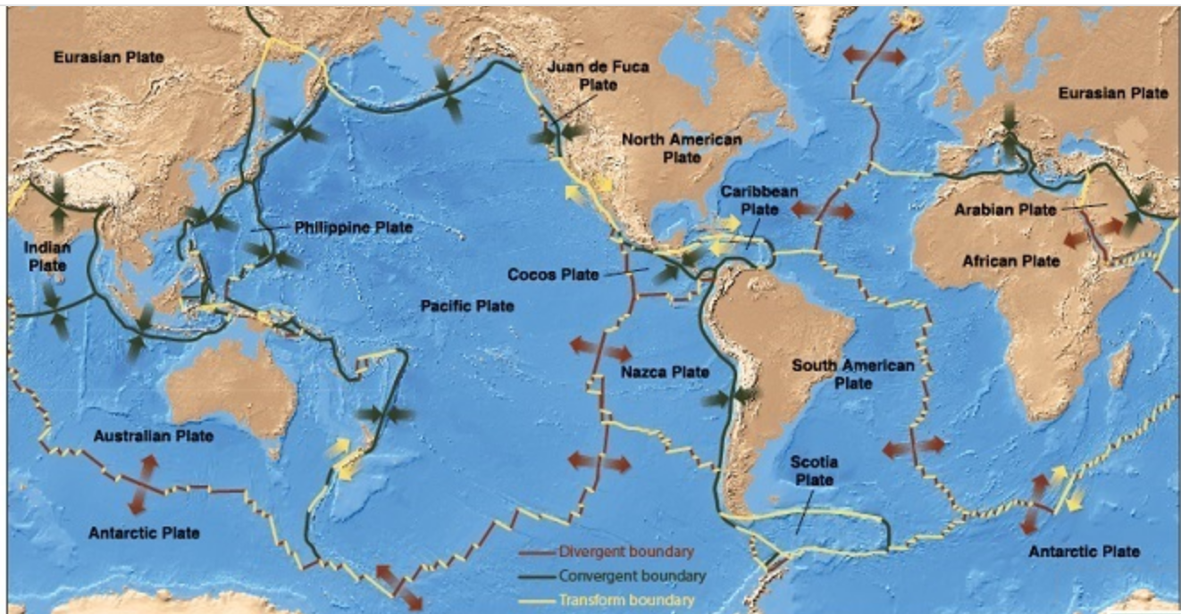
Global distribution of the three different plate types

The plates map above has a legend along its bottom that shows how each type of plate boundary is depicted. Convergent plate boundaries are represented by inward-pointing arrows, divergent plate boundaries are represented by outward-pointing arrows, and transform plate boundaries are represented by arrows pointing in opposite directions siding past each other.

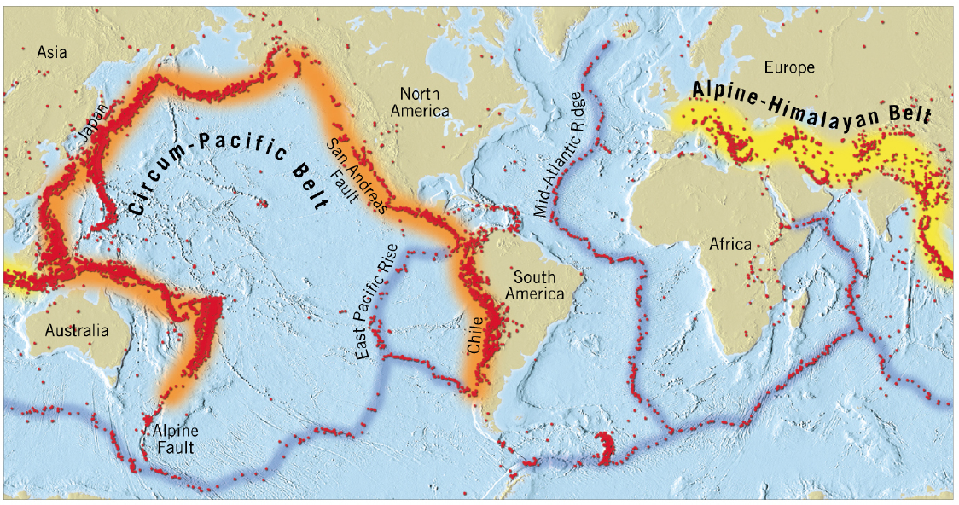
Location of epicenters for earthquakes – 10 year period

On the earthquake map above, each red dot represents the epicenter of an earthquake magnitude 5 or greater. The circum-Pacific belt and Alpine-Himalayan belt are zones of frequent earthquake activity. Notice that the circum-Pacific belt occurs along the coastlines of South America, North America, East Asia, and Australia. The Alpine-Himalayan belt is the name of a series of mountain chains that run through central Europe and Asia.

The maps show an obvious correlation between earthquakes and plate boundaries. Some plate boundaries, however, produce more earthquakes than others. Use the maps to identify which type of plate boundary is associated with each kind of seismic zone. *Pay closer attention to the arrows (relative motion) than the lines drawn on the map of the plates that divide Earth’s crust.

Categorize the following descriptions as either belonging to Convergent (inward-pointing arrows) boundaries or Divergent (outward-pointing arrows) boundaries: (8 pts)
Convergent
- Most earthquakes in mountains or near mountains are associated with this kind of boundary.
Convergent
- Most earthquakes occur along this kind of boundary.

Convergent
- Most earthquakes near coastlines occur along this kind of boundary.
Divergent
- Most earthquakes in the middle of the oceans occur along this kind of boundary.
Mass wasting is influenced by many processes associated with all four spheres of the Earth system (i.e. atmosphere, hydrosphere, biosphere, and geosphere). For example, the processes of the atmosphere impact weather events and climate change; these, in turn, impact the amount of water present on a slope, which can trigger mass wasting. The processes of the hydrosphere, such as water erosion and undercutting of slopes, can trigger mass wasting as can the biosphere – plants that stabilize slopes and animals that destabilize slopes. Processes of the geosphere, such as earthquakes, also can trigger a mass-wasting event.

Match the event, processes, or one of the spheres of the Earth system (numbers “1” through “8”) to their correct location in the table below (letters “a” through “h”). The events and processes described in each row occur within the sphere in each row. Red items go in the first column for events. Green items go in the second column for results that occur from preceding events. Blue items go in the third column for one of the spheres of Earth system. (8 pts)

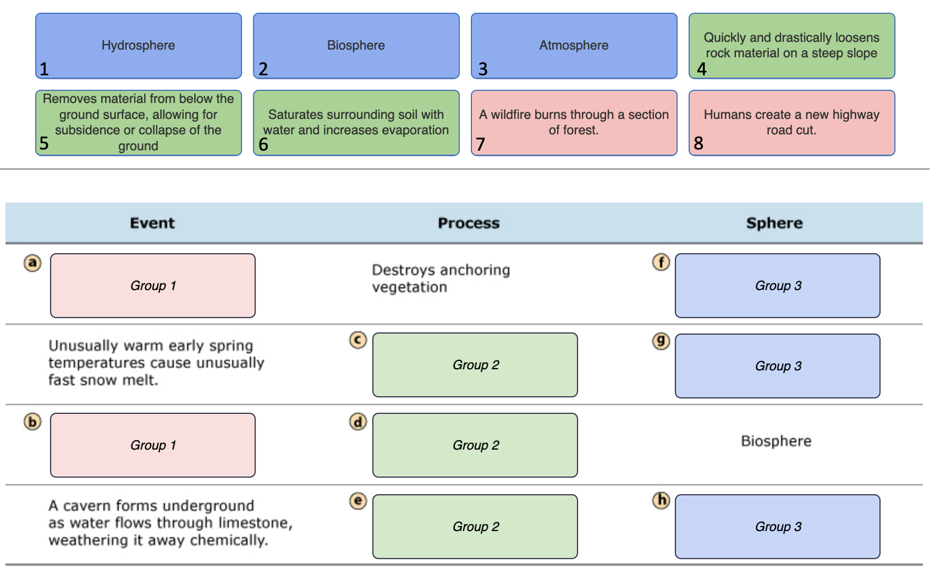

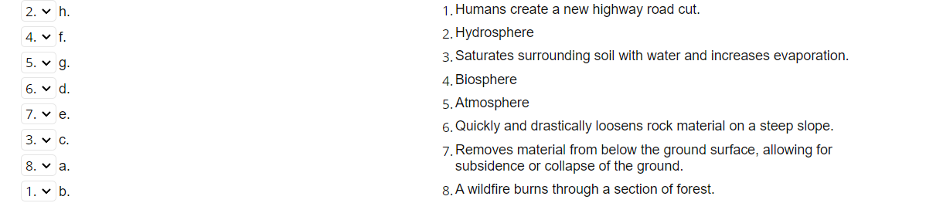
Week Eight: Running Water / Shorelines

Streamer is a map-based database of stream maps that allows you to trace upstream to the source of a river, or downstream to where it empties into a larger system (or the ocean!). Let’s examine the Neuse River in eastern North Carolina. Go to https://txpub.usgs.gov/DSS/streamer/web/ and click on the “Go to Map” button. Follow the directions below.

- Upstream Data (6 pts)
  - Locate the community of Goldsboro, NC on the Streamer map. You can use the zoom slider on the map to zoom in, or you can type Goldsboro, NC in the “Location Search” panel and then press “Enter/Return” on your keyboard.
  - Locate the Neuse River adjacent to Goldsboro. Click on the “Trace” Upstream” button and then click on a point on the Neuse River adjacent to Goldsboro, NC. All the streams that supply water to that point along the Neuse River should now show up in red.
  - Click the “Trace Report” button, and select “Detailed Report” to get a Stream Trace Detailed Report.
      - Question 1: Through how many communities does the stream flow before it gets to this point? [Cities (count)]:
      - Question 2: In how many named streams does the water flow to this point in the stream? [Stream Names (count)]:
      - Question 3: What is the total length of the streams to this point? [Total Length of Traced U.S. Streams (miles)]:
  - Close the Stream Trace Detailed Report (but not the map) by clicking on the small gray “x” in the right-hand tab labeled “Streamer Report” near the top of the browser winder.
- Downstream Data (4 pts)
  - Click on the “Trace Downstream” button and then click on the same point along the Neuse River adjacent to Goldsboro, NC that you did for the Upstream exercise above.
  - Click the “Trace Report” button, and select “Detailed Report” to get a Stream Trace Detailed Report.
      - Question 1: Into what “Outlet Waterbody” does the stream’s water eventually empty?
      - Question 2: What is the name of the last community that the stream passes through before it enters the “Outlet Waterbody”?

All streams erode downward through the rock they flow over. However, streams cannot erode below a certain elevation. The bottom limit to stream erosion is called the base level. Two facts determine the base level of a stream:
- Streams always flow downhill.
- Streams usually flow into other bodies of water such as oceans, lakes, or other streams.
As a consequence, streams can never erode below the elevation of the water body they flow into. Otherwise, they would have to flow uphill.

The figure below shows a mountain stream that has been dammed. The dam has created an artificial lake into which the mountain stream now flows. Label the diagram to specify which points are: 1) below ultimate base level, 2) at ultimate base level, 3) at local base level, and 4) above local base level for the stream flowing into the artificial lake created by the dam. *Note that the elevation of the landscape from Location B to where the river enters the sea is the same. (8 pts)

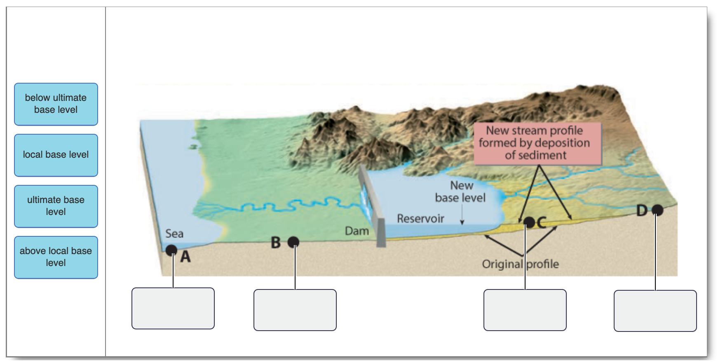
Another way to conceptualize base level is in terms of stream power. The erosional capacity of a stream is determined by its power, which is the product of its force and velocity. Thus, streams with a steep gradient have high stream power because they flow quickly and with a lot of force. Streams with a gradual gradient have low stream power because they flow slowly and with little force.
A stream’s gradient becomes increasingly gradual as the stream approaches its base level. Hence, the erosional capacity of the stream decreases as the stream approaches its base level. Ideally, the stream would have no power at its base level and would be incapable of erosion. The figure below illustrates this concept:
A - below ultimate base level
B - ultimate base level
C - local base level
D - above local base level
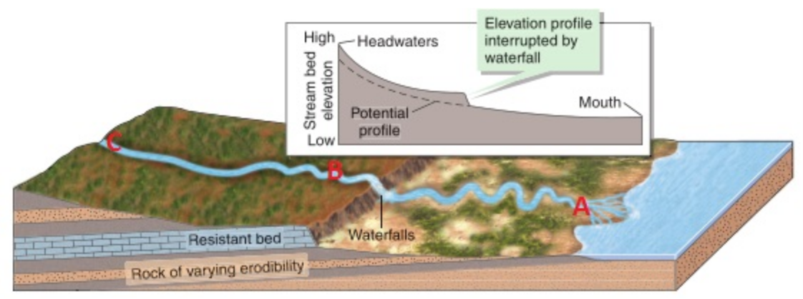

The gradual decline of the stream’s gradient can be interrupted by a resistant bed. The stream will have a uniform profile only when the resistant bed has eroded away.

Rank the labeled locations (A, B, and C) in the figure above based on stream power – from highest stream power to lowest stream power. Pay attention to the stream gradient of the three locations by using the elevation profile as a guide. (6 pts)

- C
- B
- A

